**PROJECT SPECIFICATION**

**Refactor Udagram App into Microservices and Deploy**

CI/DC, Github & Code Quality

| CRITERIA |
| --- |
| The project demonstrates an understanding of CI and Github  Project github link : <https://github.com/volkanbaran/udacity-cloud-developer/tree/master/project-3>  Travis integration has been completed. Following pictures shows git and travis integration details  .travis.yml link : <https://github.com/volkanbaran/udacity-cloud-developer/blob/master/.travis.yml> |
| The project has a proper documentation  Detail located in READ.ME file |
| The project use continuous deployments (CD) |

Travis integration has been completed. Following pictures shows git and travis integration details

.travis.yml link : <https://github.com/volkanbaran/udacity-cloud-developer/blob/master/.travis.yml>

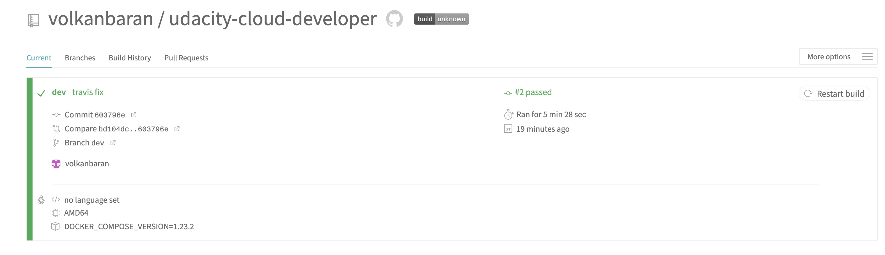

Container

| CRITERIA |
| --- |
| The app is containerized  The Project developer from referenced [starter code](https://github.com/scheeles/cloud-developer/tree/06-ci/course-03/exercises). Docker files are located under related module folder. Links for docker files listed below   * <https://github.com/volkanbaran/udacity-cloud-developer/blob/master/project-3/refactor-to-microservice/udacity-c3-deployment/docker/Dockerfile> * <https://github.com/volkanbaran/udacity-cloud-developer/blob/master/project-3/refactor-to-microservice/udacity-c3-frontend/Dockerfile> * <https://github.com/volkanbaran/udacity-cloud-developer/blob/master/project-3/refactor-to-microservice/udacity-c3-restapi-feed/Dockerfile> * <https://github.com/volkanbaran/udacity-cloud-developer/tree/master/project-3/refactor-to-microservice/udacity-c3-restapi-user>   Docker compose file is located under [udacity**-**c3-deployment](https://github.com/volkanbaran/udacity-cloud-developer/tree/master/project-3/refactor-to-microservice/udacity-c3-deployment/docker)  folder. |
| The project have public docker images  Docker images have been pushed to dockerhub account. Links for images listed below   * <https://hub.docker.com/r/volkanbaran/reverseproxy> * <https://hub.docker.com/r/volkanbaran/udacity-frontend> * <https://hub.docker.com/r/volkanbaran/udacity-restapi-user> * <https://hub.docker.com/r/volkanbaran/udacity-restapi-feed> |
| The applications runs in a container without errors  Console logs    Docker images    Docker containers |
| Application screenshot |

Deployment

| CRITERIA |
| --- |
| The application runs on a cluster in the cloud |
| The app can be upgraded via  For every module Deployment files created with at least 2 replicas. Kubernetes handles deployment without downtime. Service files are created for every module  Backend-feed  <https://github.com/volkanbaran/udacity-cloud-developer/blob/master/project-3/refactor-to-microservice/udacity-c3-deployment/k8s/backend-feed-deployment.yaml>  <https://github.com/volkanbaran/udacity-cloud-developer/blob/master/project-3/refactor-to-microservice/udacity-c3-deployment/k8s/backend-feed-service.yaml>  Backend-user  <https://github.com/volkanbaran/udacity-cloud-developer/blob/master/project-3/refactor-to-microservice/udacity-c3-deployment/k8s/backend-user-deployment.yaml>  <https://github.com/volkanbaran/udacity-cloud-developer/blob/master/project-3/refactor-to-microservice/udacity-c3-deployment/k8s/backend-user-service.yaml>  Frontend  <https://github.com/volkanbaran/udacity-cloud-developer/blob/master/project-3/refactor-to-microservice/udacity-c3-deployment/k8s/frontend-deployment.yaml>  <https://github.com/volkanbaran/udacity-cloud-developer/blob/master/project-3/refactor-to-microservice/udacity-c3-deployment/k8s/frontend-service.yaml>  Reverse Proxy  <https://github.com/volkanbaran/udacity-cloud-developer/blob/master/project-3/refactor-to-microservice/udacity-c3-deployment/k8s/reverseproxy-deployment.yaml>  <https://github.com/volkanbaran/udacity-cloud-developer/blob/master/project-3/refactor-to-microservice/udacity-c3-deployment/k8s/reverseproxy-service.yaml> |
| rolling-update  For every module Deployment files created with at least 2 replicas. Kubernetes handles deployment without downtime. Service files are created for every module  Backend-feed  <https://github.com/volkanbaran/udacity-cloud-developer/blob/master/project-3/refactor-to-microservice/udacity-c3-deployment/k8s/backend-feed-deployment.yaml>  <https://github.com/volkanbaran/udacity-cloud-developer/blob/master/project-3/refactor-to-microservice/udacity-c3-deployment/k8s/backend-feed-service.yaml>  Backend-user  <https://github.com/volkanbaran/udacity-cloud-developer/blob/master/project-3/refactor-to-microservice/udacity-c3-deployment/k8s/backend-user-deployment.yaml>  <https://github.com/volkanbaran/udacity-cloud-developer/blob/master/project-3/refactor-to-microservice/udacity-c3-deployment/k8s/backend-user-service.yaml>  Frontend  <https://github.com/volkanbaran/udacity-cloud-developer/blob/master/project-3/refactor-to-microservice/udacity-c3-deployment/k8s/frontend-deployment.yaml>  <https://github.com/volkanbaran/udacity-cloud-developer/blob/master/project-3/refactor-to-microservice/udacity-c3-deployment/k8s/frontend-service.yaml>  Reverse Proxy  <https://github.com/volkanbaran/udacity-cloud-developer/blob/master/project-3/refactor-to-microservice/udacity-c3-deployment/k8s/reverseproxy-deployment.yaml>  <https://github.com/volkanbaran/udacity-cloud-developer/blob/master/project-3/refactor-to-microservice/udacity-c3-deployment/k8s/reverseproxy-service.yaml> |
| A/B deployment of the application  In introduction section this item adressed as bones. Not implemented  Extend the application with deployments and be able to do rolling-updates and rollbacks   * Bonus: Implement A/B testing for the application. * Bonus: Monitoring and Logging for the application |
| Monitoring |